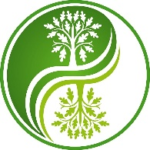
West Shires School of Complementary Health
Aromatherapy Oils Online Workshop Booking Form

Name:
Address including postcode
Telephone Number: | Daytime:  Evening:  Mobile:
Email:
Workshop Title: Aromatherapy Workshop
Date of Workshop | Saturday 13th February 2021
Please print clearly the name you would like on your Certificate of Attendance
Workshop Price | £50
Other Information:
Email form to : alliancetherapycarmarthen@gmail.com
Or post to : Please make cheques payable to
West Shires School of Complementary Health C E Hodgson
Alliance Therapy Carmarthen,
24 King Street, Bank Transfer BACS
Carmarthen 20-18-54 33637530
SA31 1BS Ref: (name or initial and workshop)

