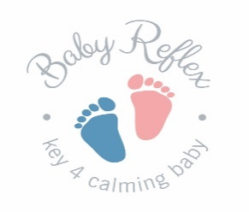

Information and Booking Form

West Shires, School of Complementary Health, Carmarthen
Tuesday 3rd and Wednesday 4th July 2018

Baby Reflex & Toddler Reflex courses are for Qualified Reflexologists & are fully accredited by the AoR.

COST: £235

Venues and full detailed requirements for delegates will be advised on booking. If you have any access needs to participate in the course, please let us know as soon as possible. We are happy and able to provide handouts in alternative format with advanced notice.

Name: …………………………………………………………………………………………...........................................................................................

Address: ………………………………………………………………………………………...........................................................................................

…………….……………………………………………………………………………………..............................................................................................

Email Address: ………………………………....……………………………………………Telephone: ……………………………...................................

Organisations you are a member of e.g. AoR, FHT: …………………………………..............................................................................

The AoR may request your contact details from Baby Reflex to gather feedback regarding our courses.

(Your details will not be passed on or used for anything other than collating feedback)

YES I am happy for my contact details to be shared with the AoR.

NO I do not want my contact details shared with the AoR.

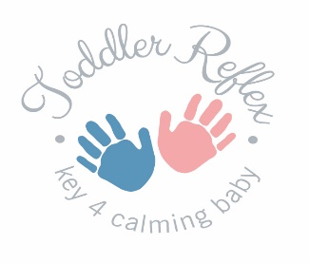
Payment Details

Payments to be made by bank transfer;
C Hodgson
Barclays Bank
Sort Code: 20-18-54
Account Number: 33637530
Reference: Baby Reflex

If you wish to pay by cheque or PayPal please contact Cheryll Hodgson on 01267 231212 or
Email alliancetherapycarmarthen@gmail.com

Email confirmation of booking will be sent.

Terms & Conditions:

We reserve the right to cancel courses and provide a full refund.

Please note if you are booking training the following cancellation policy applies. All bookings are accepted on this basis. If you must cancel coming on the course you could be subject to a cancellation fee, please see below;
Courses cancelled prior to one month before the course date – full refund minus deposit
Courses cancelled between four and two weeks prior to course date – 50% refund
Courses cancelled within two weeks of course date – no refund

We strongly advise that you take out a small insurance policy to cover any cancellation as we are unable to refund at less than two weeks’ notice as groups are small, and we have standard charges and trainer’s costs which must be covered.

Baby Reflex’s training content and brand is subject to copyright and trademark, any infringement or use of our materials without consent will result in legal action.

Signature……………………………………………………………………………………Date…………………………………………………………………………..

